A000-Afr-Gabon-Kwele- Antelope Mask-Wood-Kaolin-Late 19th c.

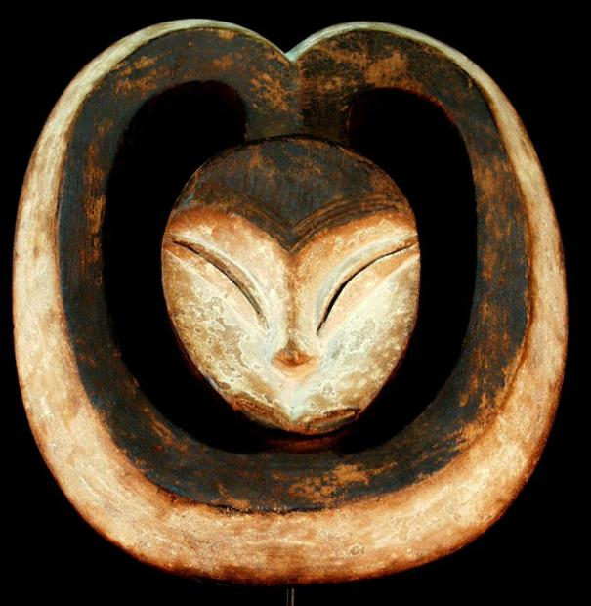

Gabon, Kwele, 12.80 inches high, 1.23 pounds

.

This magnificent mask is hand carved by members of the Bakwele (Kwele) people from Cameroon. It shows a flat surface with a heart-shaped face, a triangular nose, small eyes and a small or non-existent mouth. This mask, with two large horns, represents the antelope - a protective forest spirit. The faces are usually painted in kaolin earth, a pigment the Kwele associate with light and clarity - two essential factors in the fight against evil. These masks are traditionally hung in Kwele houses and used during ceremonies.

The heart-shaped masks, creations of the peoples of the equatorial forest, compose the first sequence of the exhibition They have their origins in the forested regions of the northern Congo and Ogooué Basin, and are most often made of concave or flat wood. The forehead and cheeks define the shape of the face and thus carve out a space in the shape of a heart, often covered with a white dye called Mpemba. The wearer of the mask is covered with leaves, vegetable fiber, or cloth. Upon its entrance on the stage, its glance delves into the life of the village. The songs, dances, and music sustain it, so that it might reawaken the collective memory.

Its role is multifold: it is a symbol of communication; it revives the identity of the group in the initiation rituals and pays homage to the ancestors and nature spirits. It must denounce the soul-eating spirits, punish the guilty or heal the sick, and then accompany the deceased.

This archetype is found among the Kwele and Fang in Gabon, until the Lega of east Congo, in present-day Democratic Republic of the Congo.

Although the mask is always of the similar structure, it changes according to the peoples and customs. Thus, the Luba sculptures, full and sinewy, strongly contrast with those of the Songye, rectilinear and angular.

The mask is part of a ceremony based on the commemoration of ancestral presences and the forces of nature. It takes its full dimension during the ritual dances.

 